**Changing the Landscape of Poverty:**

A study of GED students who left with only one test left

Michele C. Michaelis

Purdue University

Practicum EDCI 573

Dr. Mary Bonhomme

**Acknowledgments**

**Thank you to my project supervisor, Robin Beebe, who gave me the idea for this project and supported me throughout the process. I am incredibly grateful for Saturday reviewing the first rough draft.**

**My gratitude also extends to Tammy Green, who supported and permitted this project to proceed.**

**Thank you to Kaylen Michaelis for her editing expertise and Scott Michaelis for proofreading the final copy.**

**Lastly, thank the MCC students and instructors who provided valuable insight and ideas.**

**Table of Contents**

Executive Summary 4

Background 4

Contractual Agreements 4

Problem Statement 5

Objective 5

Methods 5

Literature Review 6

Insight Gained 8

Project Scope 10

Design Model & Evaluation Plan 10

Context Evaluation – Analysis Part 1 11

Input – Analysis Part 2 19

Process Evaluation – Design, Develop, Implement 38

Product Evaluation – Evaluation 41

Advantages and Limitations 43

Questions for Further Consideration 43

Conclusion 44

References 45

Appendices 47

Practicum Reflection- Narrative 54

**Changing the Landscape of Poverty:**

A study of students leaving the GED program with only one test left.

# **Executive Summary**

## **Background**

Metropolitan Community College (MCC), located in Omaha, NE, hosts an Adult Basic Education (ABE) program as one path to meeting its mission (to break the cycle of poverty through education). It offers state-funded educational programs via the Nebraska Department of Education (NDE) that are free for students. One branch of the ABE program prepares students to take and pass the General Education Diploma (GED) exam, equivalent to a high school diploma. The exam consists of four tests: mathematics, language arts, social studies, and science. Only a few students expressed interest in participating in this study. Therefore, multiple stakeholders were offered an opportunity to participate via a survey and focus group. Finally, research was conducted to see if other studies corroborate the possible high levels of math anxiety at MCC. Few students were interested in participating in this study, so small groups of various stakeholders and published research were used to verify the implications of survey results.

## **Contractual Agreements**

General database information was accessed with the approval of MCC's ABE program administrators. Students who participated in surveys and focus groups were informed of the following:

* Participation in the surveys was optional
* Identifying information would not be shared
* The benefits of participation could result in program improvements
* The study results would be shared with MCC and in a project for a Purdue Graduate school project.
* When participation seemed scarce, an offer to enter students into a drawing for a $50.00 Visa gift card was made. Only a few students seemed interested.

## **Problem Statement**

Although most students who pass three out of the four required tests go on to earn their GED, 51 students passed three tests and then dropped out. This phenomenon is puzzling. Administrators in the ABE program expressed an interest in gaining more insight into the thought processes of these students. This insight may guide the development interventions to increase graduation rates and decrease the number of students who cease their GED studies on the verge of success.

## **Objective**

The objective is to gain insight into the reasons a GED student might have for leaving their studies when there is only one test left to take. Potential interventions, if applicable, are to be based on the research related to this question and the insight gained from multiple stakeholders.

# **Methods & Literature Review**

## **Methods**

To this end, 51 students were surveyed to discover their reasons for leaving the program. One student returned to the program during the study and passed their final test. This change reduced the number of students to 50. Low interest in filling out the survey led to obtaining information from additional stakeholders. Thus, surveys went out to four groups: Former students with one outstanding test, Current students with one outstanding test, GED Instructors, and a focus group with current students (all of whom have outstanding GED tests). The focus group included a survey-based activity, and the purpose of this was twofold. The first goal was to determine what they believed might justify leaving the GED program. The second was to determine if math anxiety is relevant to this study. The questions about math anxiety were included because, in the original group of 50 former students, 90% left the program with the math test unfinished (Appendix A).

Additionally, 56% of former students left with only one or no attempts to pass the GED math test (Appendix B). These percentages were calculated using the data from MCC's database managed by LACES LiteracyPro Systems, Inc. (LiteracyPro Systems, Inc., 2021). Additionally, survey results indicated that participating former students indicated no test anxiety for the GED test subjects, except for math (Appendix D). Current students with one outstanding test reported the highest math test anxiety levels. However, they did report more anxiety for tests of any subject compared to other groups (Appendix E). Thus, including math anxiety as a possible barrier for other students seemed relevant.

## **Literature Review**

The abbreviated Mathematics Anxiety Rating Scale (MARS) is a validated assessment tool that can be reliably used to test adult populations for math anxiety rates (Suinn & Winston, 2003). The survey activity for current students with all GED tests left to pass was based on the abbreviated MARS scale (Suinn & Winston, 2003), with minor adjustments. For example, instead of asking current GED students if they feel anxious about taking a math test in college, the question was adjusted to inquire about anxiety when considering a GED math test. Another question was added to gauge how students felt about percentages, a more complicated calculation than the addition, subtraction, and multiplication problems in the original questions. Results showed that although some students reported test anxiety spanning all four GED subjects during the discussion, the modified & abbreviated MARS assessment showed that 56% of the 31 presented mathematical scenarios elicited at least some anxiety for all three participants. 70.9% of the 31 posed mathematical scenarios produced at least some anxiety for two participants. (Appendix C). Finally, these surveys were compared to published research that investigated similar topics.

One such study examined the prevalence of math anxiety on an international, multi-demographic scale. The results of that study indicated that math anxiety impacts people across cultures and throughout entire lifetimes (Croucher et al., 2022). Croucher et al. (2022) cite literature claiming that up to 93% of Americans experience some math anxiety. Skagerlund et al. (2019) investigated how math anxiety impacts performance. This research supports the idea that there is a connection between math anxiety, which is presumed to occupy working memory resources, and poor performance on mathematical tasks dependent on working memory. However, the competition for working memory resources is only problematic for specific mathematical tasks" such as arithmetic" (Skagerlund et al., 2019). Watts (2011) conducted a study that found self-efficacy was the most critical predictor of math success. However, among the large body of research on math anxiety, the acknowledgment of its widespread existence and impact on people of all ages indicates that the issue is most likely relevant for MCC.

Lastly, a pilot test was implemented to see if the video "How to Learn Math" by Jo Boaler (2021) had the potential to impact students" interpretation of mistakes and feelings of frustration. In short, Boaler (2021) explains that the neuroscience of learning has advanced far enough that we now know the value of getting the wrong answer. Rather than feeling frustrated when we are struggling, we should celebrate because this is evidence that our brain is working to make new connections. And more connections in our brains are generated when we get the wrong answer.

# **Insight Gained & Scope**

## **Insight Gained**

An outline of student reasoning trends emerged by cross-referencing surveys, focus group results, and published research (Appendices A- G; Bruno, 2015). These trends center around the following ideas:

* Health Complications
* Scheduling Conflicts
* Family Issues
* Viewing Dropping Out as Temporary

Interestingly, their answers changed when the phrasing of the question shifted to asking students why they might take a break from their GED studies. Difficulty with the subject matter suddenly emerged as a significant factor in their decision. One instructor's observation corroborated reluctance to admit difficulty or being bad at a subject that their students by stating that their students "did not like to admit to being bad at any subject (Appendix F). ""

Furthermore, even though not one of the respondents in this study, orBruno's (2015) study, cited mathematics as a barrier to completing their GED, 90% of the 50 students who left with only one unfinished test left chose to leave without completing the GED Math test. 32% did not make a single attempt to take the math test. 24% made one attempt, and 1% had no recorded data on how many attempts were made. Thus, 56% of the students who left the GED program at MCC made zero to one attempt at the math test before leaving the program. Also, when asked what anxiety students feel when considering a math test, all four groups showed a spike in math anxiety levels compared to other subjects. Therefore, despite Bano's (2015) decision to take students' reasons for leaving a GED program at face value, this report considers the significant number of students leaving with very few or no attempts to pass the math test a trend-bearing consideration.

Most reasons students cite involve factors beyond a GED instructor's control. Therefore, this project seeks to devise a systematic approach toward addressing two challenges that may be within the realm of MCC's influence. These two variables are as follows:

* Viewing leaving the GED program as a temporary solution
* Developing a resilient mindset after experiencing a setback, especially concerning mathematics.

## **Project Scope**

This project ran roughly 8 -9 weeks because an early start extended the timeframe. Although this study primarily sought to understand better why a student might leave the GED program when they are only one test away from graduation, this project does extend into developing a system of solutions, with a pilot test of one of those suggested interventions. Other learning products that were developed but not implemented include the following:

* Job aid for Instructors: Gradual Release, Utility Value Intervention & Exit Ticket Form
* Padlet Discussion Board

# **Design Model & Evaluation Plan**

ADDIE (Analysis, Design, Develop, Implement, and Evaluate) is the design model selected for this project (Reiser & Dempsey,2018). However, this project is predominantly focused on the Analysis stage. Interestingly, there are specific compatibilities between *ADDIE* and Stufflebeam's *Context, Process, Input, Product (CIPP)* evaluation model and the natural rhythm of my project (Yale, 2021; Reiser & Dempsey, 2018). For example, it could be argued that 50% of the CIPP evaluation model focuses on analysis. For this reason, the organization of this project is constructed by superimposing the design model ADDIE onto the CIPP evaluation model. The advantage of using the superimposition of the design and evaluation models is that it evaluates each step of the design process. It also ensures that the organizational mission, to break the cycle of poverty through education, remains in a central position. See Figure 1 to see how the ADDIE process is superimposed on the CIPP model.

Figure 1

**Evaluation Model: Superimposition of ADDIE and CIPP**

Diagram of the CIPP evaluation model 
(Context, Input, Process, Product) aligns with the Design model ADDIE ( Analyze, Design, Develop, Implement, Evaluate.
 

Design, Develop, Implement

Evaluate

**Process Evaluation**

**Plans**

Stakeholders

Strategy

Budget

Research

**Actions**

Develop

Implement

Monitor

Feedback

**Product**

**Evaluation**

**Outcomes**

Impact

Effectiveness

Sustainability

Adjustments

**Context**

**Evaluation**

**Goals**

Beneficiaries

Needs

Resources

Problems

Background

Environment

**Input**

**Evaluation**

Analysis part 2

Analysis part 1

(Yale, 2017; Branch, 2018)

Each section of this report will focus on one quadrant of the merged models so that the reader may follow along with the Design and Evaluation models simultaneously. At the end of each section, a brief evaluation will occur to ensure that each quadrant is. Each quadrant constitutes a new section of the paper. Please see page 12 for the section that starts the first quadrant.

Meaningful **summative evaluation** will take six months, so it can’t be collected for this project's scope. One intervention was implemented on a small group of volunteers, and their feedback indicated that Jo Boaler's video holds promise as an intervention (Boaler, 2020). Feedback from the focus group is as close as this project will come to implementing a summative evaluation. However, a **formative evaluation** will occur at the end of each stage of this project. The focus of the summative evaluation will consist of reflecting on how the process and activities of each stage connect with the central organizational mission.

## **Context Evaluation – Analysis Part 1**

Figure 2

**The First Quadrant**

Analysis Part 1

**Context**

**Evaluation**

**Goals**

Beneficiaries

Needs

Resources

Problems

Background

Environment

(Yale, 2017; Branch, 2018)

### **Goals**

This section strives to define and evaluate the project's goals in the context of the organizational mission. The topics will involve the intended beneficiaries and their needs, organizational resources, problems, background, and environment.

#### **Beneficiaries**

The intended beneficiaries of this project are MCC in Omaha, NE (MCC) and its students. The end goal is that an increased understanding of a student's mindset will result in the development of appropriate interventions. This project is intended to benefit the GED program at MCC because the program depends on the Nebraska Department of Education for funding. Therefore, anything that helps MCC's graduation rate increase means the program will retain the financial means to continue pursuing its mission to break the cycle of poverty through education.

#### **Needs**

MCC needs deeper insight into the thought processes that its students go through when they decide to drop out of the program. Additionally, a way to collect data continuously would be beneficial because obtaining this information after the student has left the GED program can be challenging to regain contact with them. Not only do students fail to pick up the phone when called or emailed, but contact information can also become outdated. Thus, gaining a larger sample of students reporting why they are leaving the program would better inform MCC's understanding of students" decision-making process over the long hall. The following gap analysis illustrates the desired and current situation and defines the gap between the two.

Table 1

**Gap Analysis**

|  |  |  |
| --- | --- | --- |
| Desired State | Current State | Gap |
| MCC Administration understands a student's thought processes with one outstanding test when deciding to leave the GED program at MCC. The insight will lead to design interventions to decrease this occurrence. | Fifty-one students from 2018- 2022 left the Registered GED program at MCC with only one outstanding test with little understanding of what is causing this occurrence. | An analysis of students" thought processes when they decided to leave with one test left is required to develop interventions. |

#### **Resources**

Financial resources for this investigation amount to two $50.00 Visa gift cards offered as a prize for a drawing. Students became eligible through survey participation. MCC's Adult Basic Education Department provided resources such as database access (LiteracyPro Systems Inc., 2021) and Microsoft 365 apps (Word, Forms, and Email), precisely the Metro South Express location. Personal contributions included a personal computer, a Kahoot account, and other research resources.

#### **Problems**

Barriers to obtaining information required to complete this study are as follows:

* Challenges contacting former students due to outdated contact information and discontinued use of their MCC email
* Low participation levels in the survey
* Time constraints
* Possible reluctance to share thought processes that leave former students feeling vulnerable

#### **Background**

Figure 3 illustrates the organizational structure of the GED program at MCC. There are two pathways that a student may opt to take. One is an open learning opportunity. In this program, a student will register as an open-learning student. They will only attend GED classes when they need the support or can. They will also work independently at their own pace. When the student feels ready to test, they will submit a request and schedule a test. From the Nebraska Department of Education perspective, they are not official students of the GED program.

Figure 3

**Organizational Flowchart**

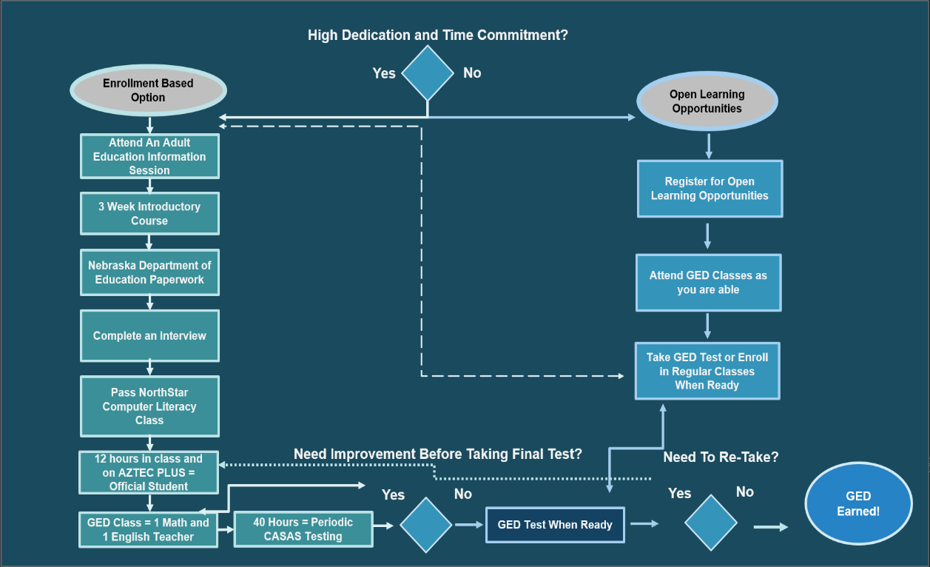

(Metropolitan Community College, n.d.)

The other pathway involves a higher level of commitment by requiring class attendance. It requires attending an introductory course to ensure students have the digital literacy skills needed for the program and are prepared for class procedures and program expectations. After 12 hours of attending an official GED class, they are classified as an official student of MCC; their decision to stay in or leave the program then becomes of interest to the NDE. This data is recorded with a Learning Management System (LMS) called Aztec Plus (2023), students" self-reporting classroom hours, and instructor confirmation of those hours. Finally, Instructors enter the collective hours in a database that LiteracyPro Systems Inc. (2021) manages. Classes are three hours long and are held twice weekly. They are a team-taught by a math teacher and an English teacher. Most students spend 1.5 hours on math and 1.5 hours on English. Once 12 hours in an official GED class have been completed, a new student is considered officially enrolled in MCC's GED program.

Once officially, MCC students in the Adult Basic Education program must take a test every 40 hours to measure growth. Students take these tests through the Comprehensive Adult Student Assessment (CASAS) organization. Once students reach the two highest ABE skill levels (level 5 and level 6) in at least one of the four required academic disciplines (reasoning through language arts, math, social studies, science), they qualify for a GED Ready test. (They only qualify for the subject they achieved a level 5 or 6 for). This assessment is a practice test to determine if the student is ready to take the official GED test. Once the Ready Test for the subject in question is passed, the student qualifies to take the official GED Test at the expense of the NDE.

The GED official requires a score of 145. If this score is not reached, the student returns to class for 40 more hours of instruction to prepare for a retake. Students are not required to take all four tests at once. Most students are encouraged to pass the reading and math tests before taking social studies and science GED tests. This recommendation is given because the social studies and science tests involve using skills measured on the reading and math tests.

#### **Environment**

From the student's perspective, the environment involves attending class at one of the MCC locations or participating in an online course. Classes are held from 9 am to noon and 6 pm to 9 pm, Monday through Thursday. Tutoring is available online from 6 to 9 pm on Tuesday and Thursday and from 9 am to noon and in person. Most students describe instructors as helpful and comfortable with their chosen environment, in-person or online. If necessary, assistance with an electronic device is provided after the student is an official student to increase access to online options and educational resources.

From the instructor's perspective, the environment varies considerably. Instructors may work as needed at any of the college's nine mainstream sites and other community areas. They may also teach online. The classes are conducted simultaneously, so there is minimal opportunity for instructors to interact with each other. Instructors can only work part-time hours and may have other full-time jobs. Most GED instructors reach in pairs, with one teacher focusing on math and the other focusing on the test, *Reasoning Through Language Arts.* Additionally, facilitators are readily available to assist instructors during class hours and any other time 9-10 during the regular Monday through Friday workweek.

MCC, as an organization, seeks to meet students where they are. According to Tammy Green (insert position title here), the GED program provides students with an online curriculum, laptop loaners, Wi-Fi, classes that meet their schedule, and three days of availability for tutoring.

#### **Context Evaluation &MCC's Organizational Mission**

Helping community members break the cycle of poverty through education is addressed in the Context Evaluation phase because the organizational structure is designed to be located at multiple locations that span the Omaha Metropolitan area. Classes are also available online. This infrastructure ensures all students can access a learning facility near their homes. This widespread accessibility to learning facilities creates increased access to learning resources and supports the organizational mission.

The organizational structure is also designed to acclimate students to testing conditions so that once the GED official test is approached, it is one test in a long series of practice tests. This organizational structure has the potential to help students with test-taking skills that may be lacking. Additionally, a robust testing structure provides frequent information about what skills students have mastered and what skills should be focused on next. This regular feedback stream ensures students spend their class and independent study time on GED-relevant skills and concepts.

However, the structure did cause some concern. Initially, the organizational structure analysis created a concern that *direct instruction* solely focuses on math and reasoning through language arts. This operational protocol might create a disadvantage for students in the subjects of social studies and science. However, an analysis of former students" outstanding tests did not support this concern. In fact, of the 50 students who left with one outstanding test, roughly 90% left the math test unfished when they left the GED program at MCC (Appendix A). This discovery is significant because math is one of the two subjects for which direct instruction is provided. Thus, one can conclude that the organization is not concerned about understanding what might be causing students to leave their GED studies with only one outstanding test. Furthermore, time and consideration have been spent setting up an organizational system. The organizational design strives to maximize its abilities to reach students where they are in terms of capacity for the time investment, maximizing academic focus where it is needed most, and considering access to classes through online or multiple in-person class sites.

### **Input – Analysis Part 2**

Figure 4

**The Second Quadrant**

Analysis Part 2

**Input**

**Evaluation**

**Plans**

Stakeholders

Strategy

Budget

Research

(Yale, 2017; Branch, 2018)

### **Plans**

The plans for this project include analyzing stakeholders, the strategy for coming up with solutions, a budget or investment analysis, and research relevant to the decision-making process.

#### **Stakeholders**

All stakeholders have compatible needs and goals. However, there are curious differences in how different groups perceive the best strategy for obtaining the goal: to reduce poverty-level wages through education. Instructors, facilitators, and Administration have achieved significant academic success as all have at least a bachelor’s degree. Among this group, there seems to be a sense that one should enter an education program and continue until passing all classes needed for graduation. When such a mindset is taken for granted, understanding the thought processes behind dropping out of an educational program is a puzzle, especially when a person has only one hurdle left to graduate.

However, the surveys indicate that GED students make more allowances for taking a break as a strategic move for dealing with challenges and balancing their education path with competing interests. Students who left the program with one test remaining also tended to characterize dropping out of the program as temporary (Appendix A). In the back of their mind, they believe they will someday return to finish their final test. These students requested that they be kept in the loop about when classes start up again so they can decide if it is an excellent time to return (Appendix A). They believe they will return to finish when circumstances change and feel decompressed from the stress of failing a GED test, especially if they failed it more than once (Appendix A).

As mentioned earlier, when students are asked why they left the GED program, their answers highlight life circumstances outside MCC’s control (ex.- health, family needs, and conflicting schedules (Appendix A). However, when asked what might cause them to take a break from their GED studies, subject matter difficulty is cited as a reason (Appendix B). To underscore this change, one instructor indicated that the students in their class " did not like to admit that they were bad" in any GED subjects (Appendix F).

These insights were compared with Bruno's (2015) research, which concluded that life circumstances were the most often cited reasons for dropping out of a GED program. Due to the reasons students cited, Bruno (2015) took these reasons at face value. So, although the students in Bruno's (2015) study parallel the reasons former students in MCC's GED program cited, the results of this study indicated that there might be more to the story than meets the eye.

In addition to students citing subject matter difficulty as a reason for taking a break, information in the database seems to support the idea that subject matter difficulties may be an underlying issue. Curiously, like the students in Bruno's (2015) study, not one of MCC's students cited math as a reason for taking a break or dropping out of the program. However, as previously stated, 90% of those who dropped out with one test chose to leave math as the topic for their final test. Most students made either one or no attempts to pass the mathematics test before dropping out. Furthermore, all four surveys and the focus group discussion indicated that math induced more anxiety than any other subject (Appendices A- G). Furthermore, most students indicated that if a class designed to help them with math was designed for those who struggle with the subject, they might be interested in attending (Appendices A-E). Based on these observations, this study will place importance on developing a healthy mathematical mindset and the development of resiliency when facing setbacks in any subject matter.

#### **Stakeholder Analysis**

Table two identifies the stakeholders and states what they want and need. Listing all stakeholder's wishes can unearth conflicts of interest and provide an opportunity to remedy those conflicts sooner rather than later. Also, it increases the chance that stakeholders will be satisfied with the results. Figure 2 outlines the needs and wants of stakeholders relevant to this study.

Table 2

**Stakeholder Wants and Needs**

|  |  |
| --- | --- |
| Stakeholder | Needs & Wants |
| Former GED students with one test left undone. | Wants to be informed about when classes start so they know when they can return to the program (Appendix A)  Wants to feel successful and capable in the subject matter they are currently testing.  Needs alternative strategies for overcoming barriers other than taking a break  Students need to understand the risks of losing momentum when taking a break. |
| Current students with one test left undone. | This group of students reported wanting extra assistance with subjects that they find challenging and a more significant social media presence to encourage people to sign up for the program (Appendix B) |
| Current students with no GED tests passed- | This group wants to spend time gaining skills in the GED. They expressed a desire for more accessible tutoring times, particularly in the subject of math (Appendix G) |
| Instructors | Instructors desired increased professional training on current online programs used as curriculum resources and student progress data. One instructor suggested that the Adult Basic Education program hire a professional trainer; another suggested that time to exchange ideas with other instructors would be beneficial (Appendix F).  Survey results indicated a need to be introduced to learning interventions such as Utility Value interventions and other learning science concepts (Appendix F ). |
| Facilitator | Facilitators want to be and are interested in supporting instructors and students. Moreover, they want continuous information about student thought processes to help improve the organization. |
| Administration | Administrators are concerned with ensuring the GED program at MCC complies with the state of Nebraska regulations and remains operational.  They also want to understand students' thought processes when they decide to leave the program, especially when there is only one test left to take. |
| NDE | The NDE wants to support its residents in obtaining the education and skills they need to increase opportunities for higher education and career education (Neb.gov, 2023). |

#### **Strategy**

Devising a good strategy begins with considering the stakeholders" wants and needs and devising possible solutions.

#### **Exploration of Possible Solutions**

The solutions proposed are not the recommended actions. Instead, the solutions listed detail possibilities that may or may not be feasible. Table 3 identifies possible non-instructional and instructional solutions to address stakeholders" wants and needs.

Table 3

**Problem- Solution Analysis Based on Stakeholders" Interests**

|  |  |
| --- | --- |
| Problem | Possible Suite of Solutions |
| Former students desire easy access to information about when classes can be re-entered. | Non-Instructional Solutions:   * Post-GED registration dates and times on MCC's GED website * Email or Call students to let them know when registration for the next session begins * Post opportunities to enter or re-enter on various social media platforms * Inform Exiting Students that they must call to find out when classes start again. |
| Challenges are obtaining extra help or scheduling conflicts with tutoring times. | Non- Instructional Solutions   * Offer tutoring Monday through Thursday so students in an evening class on Tuesday and Thursday can obtain extra help. * Allow instructors to work half an hour before or after class to provide one-on-one or small-group tutoring as needed (Appendix G). |
| Testing anxiety and feeling overwhelmed when facing academic challenges | Instructional Solution   * Implement a learning module or class focus groups that introduce students to the current neuroscience of learning to teach about the growth that happens when frustration is felt, the plasticity of the brain, and the value of getting the wrong answer, especially regarding interacting with math. * Implement Utility Value Interventions as exit tickets & instructions for Gradual Release teaching techniques, especially for math (Appendix H) * Educate students about the advantages of staying in a program through difficult times and the disadvantages of a start-stop strategy for earning the GED. |
| Instructors need increased professional training and knowledge of recent developments in learning science and science intervention  strategies such as Utility Value Intervention (UVI) and gradual Release (Appendix H). | Instructional Solution   * Implement a learning module or class focus groups that introduce students to the current neuroscience of learning to teach about the growth that happens when frustration is felt, the plasticity of the brain, and the value of getting the wrong answer, especially as it pertains to interacting with math (Boaler, 2021). * Implement Utility Value Interventions as exit tickets, especially for math (Appendix H).   Non-Instructional Solution   * Provide opportunities for instructors to collaborate and exchange ideas. This discussion board could be arranged for in-person gatherings or a quarterly opportunity to exchange ideas online. Another way this could be accomplished is by creating a Padlet for instructors to ask questions and exchange tips and tricks (Appendix I). |
| Facilitators and Administration want better insight into the student thought processes and why they might drop out with only one test left. | Non-Instructional Solution   * When instructors register students for the next session, those not planning to return will be asked to complete an exit survey. This exit survey will create a regular stream of information while contact information is current and an instructor is present to help them understand how to fill out the form if necessary. This survey is yet to be designed and is out of the scope of this project phase. |

The next step is to conduct a risk analysis of these proposed solutions. This next step is a strategic process to determine feasible and sustainable solutions. Please see this analysis on page 27.

### **Risk Analysis & Projected Investments (Budget, Time, and Scope)**

The budget is a universal constraint, along with investments in time and scope (Rose, 2014). Even if there is little to no budget available for this project, there will still be an investment of time and resources. Moreover, the project will need to be timebound to be effectively evaluated. Table 4 analyzes the possible solutions and outlines a risk analysis for each.

Table 4

**Constraints- Budget, Resources, Time, and Scope**

|  |  |  |  |
| --- | --- | --- | --- |
| Possible Solution | Projected Investment | Projected Gains | Potential Barriers |
| Post-GED registration dates and times on MCC's GED website and or social media | Posting and updating posts on multiple sites may be too time-consuming with the current personnel availability. | Students who do not have current contact information listed with MCC can see when they can re-enter the program and make arrangements to prepare for the time investment at their convenience. | Currently, the website is static in presentation. Changing information will require periodically changing the webpage for the GED program. These changes are currently housed under the IT department and may not be accessible for continuous updates. This idea is a significant endeavor and is outside this project's scope. |
| Email or Call students to let them know when registration for the next session begins | This intervention would involve a high investment in time as many students have left the program. Moreover, we currently have to gauge whether they intend to return. | A personal conversation with former students may give them a sense of importance and value. This emotional connection could provide just enough support that they feel welcomed and empowered to return to the GED program at MCC. | A lack of current or updated contact information prevents students from checking their school email.  Furthermore, even if students say they intend to come back, this is not a guarantee that they will. |
| Increase availability for tutoring, especially with math. | This Investment could be up to $25.00 per tutoring session. An additional three hours of tutoring availability on Mondays and Wednesdays would cost approximately $150.00 a week per tutor. | Students may have more opportunities to obtain help and decreased odds of being unable to obtain tutoring. | MCC GED Administrators report that Investment in providing extended tutoring hours has financially and organizationally been implemented in the past. However, students did not utilize the extra support, and the collected data on the program does not support the idea that this Investment would have a desirable impact on student success. |
| Post opportunities to enter or re-enter on various social media platforms | This intervention would require personnel responsible for posting and responding to social media posts. The cost of hiring an intern to monitor social media could be at least a part-time salary. Given the limited funds to run the program, this is not desirable. | Opportunities to reach people in the Omaha Metro area who are unaware of the GED program may choose to enter it, hence increasing community outreach in its pursuit to break the cycle of poverty through education. | The amount of time would require personnel who have time to monitor all social media platforms.  Current staffing does not allow for investing time in such a campaign. Nor is it economical to suggest hiring more personnel as a solution. |
| Provide instruction during an introductory class about the consequences of approaching GED through a start-stop approach rather than persisting through challenging times. | Low no financial investment. Time would be required to organize the research and develop a learning module or learning experience to help incoming GED students understand the impact that repeated stops and starts have on their odds of success. | Suppose students are introduced to this idea during the introductory class, and instructors systematically revisit the concepts with students throughout the semester. In that case, there may be an increased understanding that "taking a break" is risky. | Convincing students that "taking a break" is not in their best interests may be challenging. It may take more than just one experience to help them understand that working through hardship, rather than waiting for circumstances to change, is the fates way to their goals. |
| Expose instructors and teachers to Jo Boaler's (2021) "How to Learn Math" " video. | The material is accessible online and can be accessed by anyone. Instructors could be introduced to the concepts in the following way: 1. Watch the videos on their own  2. Watch them with their students the videos by watching on their own time and share them with their students | Encountering some neuroscience of learning concepts may help instructors and students reframe how they interpret uncomfortable feelings when encountering challenges. This knowledge may increase resilience when difficulties are encountered. | Constraints for this proposal may involve rethinking how learning happens and may be best presented by a facilitator to guide discussion before and after watching the video. Looking for a volunteer to do this could be challenging, although it is certainly possible. |
| Implement Gradual Release and Utility Value Interventions (UVI) as exit tickets, especially for math. | Using a standard Utility Value Intervention (UVI) as an exit ticket would cost nothing financially beyond training instructors about what it is and how to use it. This training could be completed in a single training experience, either in person or online.  Gradual Release is a way to assist students but gradually give them more responsibility for problem-solving. It should also be on a job aid so instructors can effectively teach students how to use the exit tickets for a UVI assignment. | Training instructors on standard interventions. Learning science topics and instructional design strategies such as UVI would strengthen the knowledge base of current instructors and provide an opportunity to | Someone will need to design a job aid or a short module on the intervention and how to use it (Appendix H). |
| Create a Padlet for instructors to ask questions and exchange tips and tricks. | Up to three Padlet discussion boards can be created and used for free. (Padlet, n.d.). See Appendix I for a sample. | Discussion boards can be created, and instructors can post questions and exchange ideas at their convenience. | It is unknown how familiar instructors are with this technology. A job aid or video may be required to assist instructors in participating. |
| When instructors register students for the next session, those not planning to return will be asked to complete an exit survey. | The time investment in creating the questionnaire form would require time.  Implementing the exit survey would help instructors guide students leaving the program to fill out the form while assisting returning students with registration procedures. | A current stream of information could help MCC stay current with students'' reasons for leaving the program before they leave. This strategy would sidestep the challenge of being unable to collect data from students when contact information becomes outdated. | Some students may register for the next session and then drop out before we can implement an exit survey. Other students may refuse to fill out the form.  Students may answer the questions differently depending on the phrasing. Asking students why they are taking a break from their GED studies may yield different results than asking them why they are leaving the GED program. |

#### **Recommended System of Solutions**

The final recommendation involves designing and implementing both non-instructional and instructional solutions. This collection of solutions was chosen for their low-cost (or no-cost) financial Investment and viable time commitments. In addition to financial concerns, a potential for a positive impact on MCC's Instructors and students were also prioritized.

* Create a job aid that instructors can use to understand and implement an exit ticket. For example, at the end of each class, students could fill out a UVI-based exit ticket and can be asked to explain one problem they solved correctly during each class. This activity will help students "percolate" on the idea that they can solve problems successfully and enhance understanding by contemplating the relevancy skills.
* Provide instructors with access to Jo Boaler's (2021) free online video "How to Learn Math. "And use a job aid to guide class discussion. Having this information at their fingertips and a job aid will help them spot opportunities to refer to these concepts continuously during class at opportune times. Again, this helps keep the grounds continually "saturated with science-based facts that they can use to construct better strategies and decision-making processes when coming up against academic challenges and other barriers they encounter in life.
* Instructors will use the job aid and Boaler's (2021) free online video "How to Learn Math" to lead a discussion with students. Once instructors are familiar with the contexts of this video, they may facilitate its introduction to their students. This video provides an example of information about how the brain learns. The video supports the idea that anyone can learn complex things, especially math. Once this information is introduced, the instructors should nurture these ideas at some point in every class.
* A Padlet for instructors will be created as a forum to test the effectiveness of exchanging ideas and questions with other instructors online (Padlet, n.d.).
* A sample questionnaire will be developed, and further study on implementing an exit survey to provide a stream of data about why and when students leave the GED program at MCC. This data could also be used to evaluate the effectiveness of the other interventions over a longer duration. This questionnaire is yet to be designed and developed and is out of the scope of this project phase.

While listing these solutions is a start, these interventions should not be considered separate and isolated. The mission statement recognized that poverty is a cycle. We cannot disrupt the momentum in a self-perpetuating cycle of poverty by holding up a stop sign. Doing such a thing is like pouring a glass of water into a carton of milk and then being disappointed when diluted milk comes out. It is not one person who brings in a self-defeating thought process. It is an entire cycle with fierce momentum. Moreover, the development of our students'' beliefs and their apparent lack of reservoir resilience culminate in a life's worth of constructing knowledge designed to survive within the context of that fierce momentum. We will not readily convince them to give up survival tactics and thought processes that have allowed them to survive thus far.

Instead, we must find a way to gradually seep into the fierce current created by the cycle of poverty by repeatedly providing a consistent stream of experiences designed to create a need to construct a mindset compatible with completing the GED. We can permeate the cycle and guide students in constructing a better way to "swim out of poverty's current. "

Consider the following metaphor: Suppose we start by "seeding" the sky with information about the science of learning. For example, few may understand the importance of using a new skill and finding the wrong answer. In these moments of apparent failure, growth occurs in the brain (Boaler, J. 2021). Boaler (2021) states that the brain is like a muscle. Moreover, when it gets a workout, the pain sensation may be present.

Nevertheless, this is evidence that the brain is growing. This uncomfortable sensation is in direct parallel to the growth in our muscles when we are sore after a workout. Those feelings of frustration and failed attempts may feel uncomfortable.

Nevertheless, this is evidence that growth is occurring and that the learner has been successful. A first encounter with this knowledge could be considered a seed that can accumulate hope and resilience. It can be considered authentic because it offers a scientific reason to interact with the pain of frustration and setbacks more productively.

As GED educators, we should consider ourselves cloud seeders. Moreover, we should repeatedly seed the sky with the kinds of "seeds' students will most likely place their hope and trust in. The goal is that faith in these ideas will accumulate on these "seeds." Eventually, it will rain.

However, success in this part of the cycle will not be enough. In this metaphor, the ground has been a desert for quite some time. Continual seeding of the sky must continue so that rain falls frequently. The ground must become saturated. Once the ground is saturated, the waters will begin to slide down in rivers and down the mountains of doubt into a reservoir of resources. Moisture will seep into the ground where the new thought processes percolate and seep toward underwater rivers. The heat of a setback may cause some of the water in the reservoir to evaporate. However, over time this will happen without the reservoir of water running dry. Slowly, the landscape is transformed. Thus, too, are our students. Consider Figures 5 & 6 to visualize these systemic processes.

Figure 5

**System of Solutions – Cloud Seeding Strategy**





**Instructors “seed the sky” with learning experiences that promote resilience and persistence.**





**The value of struggling during the learning is experienced and celebrated. Over time the process begins to form into a pool and becomes a reservoir of resilience.**

**Instructors receive support and training to help students to absorb and percolate new concepts.**

(NOAA, n.d.)

Now, let us place our selected solutions within a similar framework. See Figure 6 to visualize these solutions as an intertwined system.

Figure 6

**Project-Specific System of Solutions Model Based on the Water Cycle**



**SEEDS**

**1. Provide instructors with access to Jo Boaler’s (2021) free online video “How to Learn Math.”**

**2. Show the value of persistence over taking intermittent breaks.**

**3. Model self-talk when mistakes are made.**



**5. Celebrate the “pain” of making mistakes as signs of growing brain connections or “muscle power” Provide more coaching during class to build managing emotions related to mistakes.**

4. Percolate through use of Exit Tickets with gradual release and UVI techniques. Instructors coach working through mistakes every class. Persistently practice the principles behind the seeds. Instructors exchange ideas via Padlet.

**Exit Survey to gather information that can be used to evaluation the long-term impact of the program and gain up dated insight regarding why students leave the GED program.**

(NOAA, n.d.)

#### **Research**

Research for this project involves obtaining information about students' thoughts and feelings surrounding two things:

* Understand what students think when they leave the GED program
* Increasing understanding of how students feel about math compared to other subjects.
* MCC's database through Laces Pro Literacy, 4 Surveys, a Focus Group, a pilot test, and published research papers serve as the primary sources of information.

**Input** **Evaluation & MCC's Organizational Mission**

The metaphor for the system of solutions aligns with the mission to break the cycle of poverty. However, this proposal does challenge the mission in that its approach does not involve "breaking" a poverty cycle. Instead, it seeks to gently infiltrate the cycle of poverty and let a steady flow of new understanding slowly alter the landscape. Ultimately, such an approach supports the end goal of the mission, which is to help people build fruitful economic lives.

## **Process Evaluation – Design, Develop, Implement**

Figure 7

**The Third Quadrant**

Design, Develop, Implement

**Process Evaluation**

**Actions**

Develop

Implement

Monitor

Feedback

### **Actions**

#### **Develop**

Due to the limited time frame for this 8-week class, the development of the suggested interventions is currently limited. Jo Boaler's (2021) video was placed in a Kahoot presentation (Appendix G). The Kahoot consisted of questions to test participants' attitudes toward struggling, particularly with math challenges. [Click here to see the video.](https://youtu.be/oa5fEYcoMvU) These questions were based on the modified abbreviated MARS anxiety scale (Appendix C). The Kahoot presentation was developed to test the potential for impact on students'' beliefs about what struggling with challenging content signifies, especially in math.

Another intervention developed involves a job aid for instructors to understand and implement an exit ticket that employs the UVI. [Click here](https://acrobat.adobe.com/link/review?uri=urn:aaid:scds:US:d6516fa2-2a2f-3d51-a493-73540197bd2c) or see Appendix I for the job aid and the exit ticket. Finally, a Padlet Discussion board has been set up. Pending administrative approval, this or a similar MCC-sponsored discussion board will be announced and available for instructors to exchange ideas, discuss the results of implementing the system of solutions, and offer ideas to improve the interventions.

#### **Implement**

Only one of the proposed interventions was implemented on a small scale. This intervention was the exposure of Jo Boaler’s (2021) video "How to Learn Math." The video explains recent neuro-research as it pertains to learning science. Moreover, it debunks many math learning myths. Unfortunately, there were technical challenges, so the survey designed to test the impact of this video had to be used as a discussion guide to obtaining information. One focus group student was asked how they interpreted the experiences of getting the wrong answer or the feeling of struggling with challenging math material before and after watching the video. Students seemed to frame the meaning of struggling differently after the video. Based on the participants of the focus groups, Boaler's (2021) video has the potential to reframe how students interpret the feeling of struggling with challenging material or experiencing getting the wrong answer. Therefore, this intervention is recommended for large-scale implementation and testing for efficacy.

#### **Monitor**

Plans to monitor the effectiveness of the proposed system of solutions will involve long-term monitoring through analysis of students' retention levels, especially once students pass three out of four tests on the GED. Retention levels will be the ultimate test to determine if students' thought processes have been correctly interpreted and if an effective system of solutions has been implemented. Short surveys on exit tickets for current students and an exit survey for students who choose not to register for the next semester will help MCC's ABE department monitor trends in student thought processes and the reasons provided for dropping out.

#### **Feedback**

Robin Beebe, project supervisor, and Adult Education Transition Coordinator, will provide feedback on the solution system. Pending approval from Robin Beebe, Tammy Green, Director of Workforce & IT Innovation- Career Skills, will receive a copy. Before this report's completion, Tammy Green asked if the results of this report could be shared with the NDE. If she approves of the report's content and professionalism, there is a possibility that feedback from the NDE may be available. Hopefully, the implementation of exit tickets and exit surveys will allow students to gather feedback on the system of solutions' impact on them. Other opportunities for feedback will include the Padlet discussion board set up for instructors and administrators.

#### **Process Evaluation & MCC's Organization**

The intervention system supports the organizational mission because it involves multiple supports to assist GED students in transforming their mindsets and sense of self-efficacy. This plan is organized so that systematic implementation of organized interventions maximizes the potential to increase a student's overall capacity for resilience. A vital component of this system is that intervention implementation includes regular coaching during classroom challenges.

## **Product Evaluation – Evaluation**

**Quadrant 4**

**Product Evaluation**

**Outcomes**

Impact

Effectiveness

Sustainability

Adjustments

### **Outcomes**

#### **Impact**

This project's scope does not include full implementation or evaluation of the proposal. However, the recommendation for implementing and evaluating involves a recommended period of 6 months followed by a summative evaluation. A summative analysis at the one-year mark would then follow this. G gains are expected to be incremental and involve testing over two to three years because mindsets are difficult to change. Moreover, lasting changes usually require well-developed relationships to take hold. Thus, it should be expected that enough time is given for new students to develop those relationships with their instructors and that instructors are well-versed and practiced in the recommended strategies.

#### **Effectiveness**

Effectiveness on a large scale will be determined by the following:

* A decrease in students who leave the GED program with only one test remaining as a result of:
  + Increased beliefs compatible with self-efficacy
  + Increased interpretation of feelings related to struggling with challenging material is a positive sign
  + Increased ability of GED students to articulate the value of what they are learning in a personally meaningful way
  + Increased awareness of how to manage test anxiety, particularly in math

#### **Sustainability**

The low cost of the interventions and the inclusion of free resources make this project highly sustainable. Small changes in the class routine may be required. However, carving out 5 to 10 minutes for an exit ticket to review instructional concepts and reinforce self-efficacy is well within the definition of good instructional practice. In short, such a practice has no chance of hurting educational outcomes. Still, it is highly likely to improve educational outcomes (cite research on exit tickets and end-of-the-class review). Given the low cost of the recommended system of solutions, sustainability would depend on the willingness of key participants.

#### **Adjustments**

It is recommended that feedback avenues (as previously described) be monitored monthly to determine if adjustments need to be made. Multiple stakeholders should be solicited for feedback throughout the tenure of the project. Adjustments should be based on that feedback.

#### **Product Evaluation & MCC's Organizational Mission**

This project's sole value is moving the needle concerning MCC's ABE outreach efforts. This project focuses on a subset of the community MCC seeks to support, namely GED students who left the program with only one test to pass. Evaluating the learning products and interventions is designed to prevent the impulse to cease GED studies and should be measured by student retention and graduation rates.

## **Advantages and Limitations**

This project's advantages include understanding that GED students approach their educational journey with a mindset that taking breaks is a standard and effective strategy for balancing competing interests. When they drop out of the program, they tend to see it as temporary and intend to return when circumstances change or they have recovered from failing a GED test. Thus, the original goal of this project has revealed some insight into the mindset of a GED student. Limitations exist because of the small number of participants. The lack of time to pilot the system of solutions as a unit rather than testing individual interventions is also a limitation of this project as it currently stands.

## **Questions for Further Consideration**

Questions that recommend being pursued in the future are as follows:

* Does the tendency to provide uncontrollable life circumstances as a reason for dropping out of the GED program but cite academic or testing challenges for taking a break represent the larger population of GED students?
* What is the impact of coaching instructors to identify spontaneous opportunities to reinforce Learning science intervention strategies during instruction vs. providing job aids?
* How do we support instructors in transforming student belief systems if they also hold static beliefs about being bad at a specific subject?

## **Conclusion**

Identifying student beliefs about struggling with new content and the feeling associated with getting the wrong answer is one thing. However, helping them construct a new belief system that will enable an increased degree of resiliency and persistence is another thing altogether. As MCC seeks to break the cycle of poverty, it may need to consider that the imagery of breaking something may not be an effective model for changing hearts and minds. It may be better to spread seeds rooted in the learning sciences that have the potential to attract learners and help them construct new ways to interpret the significance of feelings associated with feeling overwhelmed and intellectually challenged. Reframing these feelings from indicators of limited intelligence and failure into evidence of growth could be a game changer for these students. However, they will require persistent coaching and reminders to absorb these beliefs truly. Hopefully, over time, these ideas will not break the cycle of poverty but transform the systemic landscape in which it resides.

## **References**

Aztec Software, (2023). Products. Aztec software.

[https://www.aztecsoftware.com/shop/?filters=series[42-41-40-46](https://www.aztecsoftware.com/shop/?filters=series%5b42-41-40-46)]. Retrieved 2/25/23.

Boaler, J. (2021). How to Learn Math. YouTube.<https://www.youtube.com/watch?v=bxrPy1fjVU4>

Branch, Robert M. (2018) Chapter 3 Characteristics of foundational instructional design models.

Bruno, A.J. (2015) Do mathematics test anxiety influent the decision to drop out? Doctoral

dissertation, Miami University.

Croucher, K; Permyakove, K.; Turdubaeva, E.; Eskicorpci, N.; Stanalivea G.; Orunbekov B.;

Rimkeeratikul S. (2022) A general math anxiety measure. Education Sciences; 12(6): 370

<https://doi.org/10.3390/educsci12060370>

LiteracyPro Systems Inc., (2021). Home | LiteracyPro Systems. Literacypro.

<https://literacypro.com/> Retrieved Feb. 25, 2023.

Metropolitan Community College (n.d.) - GED Program. MCCNEB.

<https://www.mccneb.edu/Prospective-Students/Student-Tools-Resources/Adult->

Education/GED-Program. Retrieved 2/23/23

NOAA (n.d.) Water cycle | National Oceanic and Atmospheric Administration. Noaa.

https://www.noaa.gov/education/resource-collections/freshwater/water-cycle

Padlet, (2023, February 25). Padlet Memberships. Padlet. https://padlet.com/memberships

Reiser, Robert A., Dempsey J.V. (2018) Trends and issues in instructional design and technology

(Fourth) Pearson Education (pages 23-25). New York, NY.

Rose, Kenneth (2014) Project quality management: Why, what and how (second edition). J. Ross

Publishing. Plantation, Florida

Skagerlund, K., Östergren, R., Västfjäll, D., & Träff, U. (2019). How does mathematics anxiety

Impair mathematical abilities? Investigating the link between math anxiety, working

memory, and number processing. *Plus One*, *14*(1), e0211283.

Suinn, R. M., Winston, E. H. (2003). The Mathematics Anxiety Rating Scale, a Brief Version:

Psychometric Data. *Psychological Reports*, *92*(1), 167–

173. <https://doi.org/10.2466/pr0.2003.92.1.167>

Watts, B. K. (2011). *Relationships of mathematics anxiety, mathematics self-efficacy and*

*mathematics performance of adult primary education students*. Capella University.

Yale, U. (2017). CIPP Model | Poorvu Center for Teaching and Learning. Poorvucenter.

<https://poorvucenter.yale.edu/CIPP>.

## **Appendices**

**Appendix A**

**Former GED Students with One Test Left**

[Click here for the full survey results](https://1drv.ms/x/s!ArL4V-vhEgNlgYw379kuw2o2BnKtMw).

**Appendix B**

**Former GED Students with One Test Left**

[Click here for the full survey results.](https://1drv.ms/x/s!ArL4V-vhEgNlgYw379kuw2o2BnKtMw)

**Appendix C**

**Adapted and Abbreviated MARS results with current Students (All Four GED Tests Outstanding)**

[Click here to see the full results](https://1drv.ms/x/s!ArL4V-vhEgNlgYw7Hy-9lEe-NfS6sA?e=Bs1RPa)

(Suinn et al., 2003)

**Appendix D**

Science Test Anxiety

[Click Here to see the Full Survey Results](https://1drv.ms/x/s!ArL4V-vhEgNlgYw2YwEN-Qu3NzzA-w)

**Appendix E**

**Subject Related Test Anxiety: Current Students with One Test Left**

[Click here to see the full results](https://1drv.ms/x/s!ArL4V-vhEgNlgYw-K6mDqklSa5mjCg).

**Appendix F**

**GED Instructor Survey**

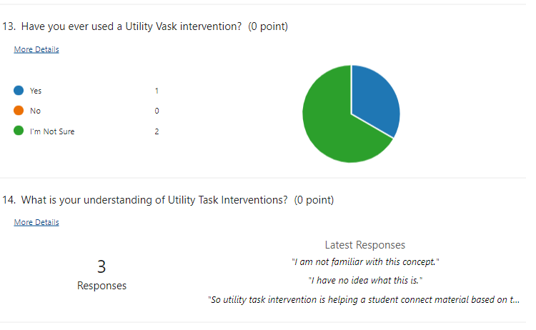

Have you ever used Utility Value Intervention?

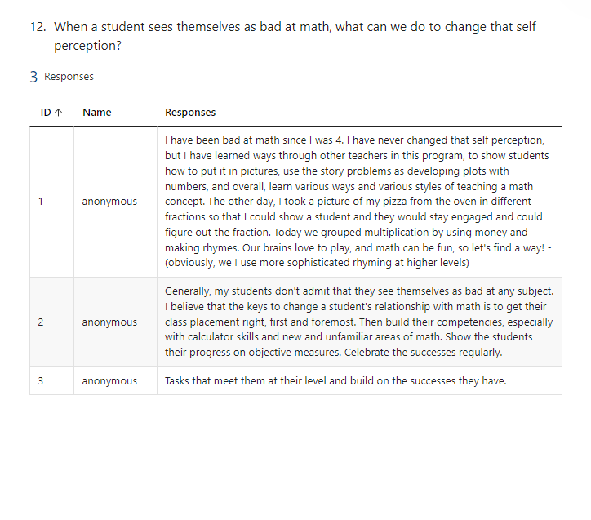

[Click here to see the full Instructor survey.](https://1drv.ms/x/s!ArL4V-vhEgNlgYw_9pYijTo4HSSKRw)

**Appendix G**

**Focus Group Discussion Questions – Current Students (All Four Tests Outstanding)**

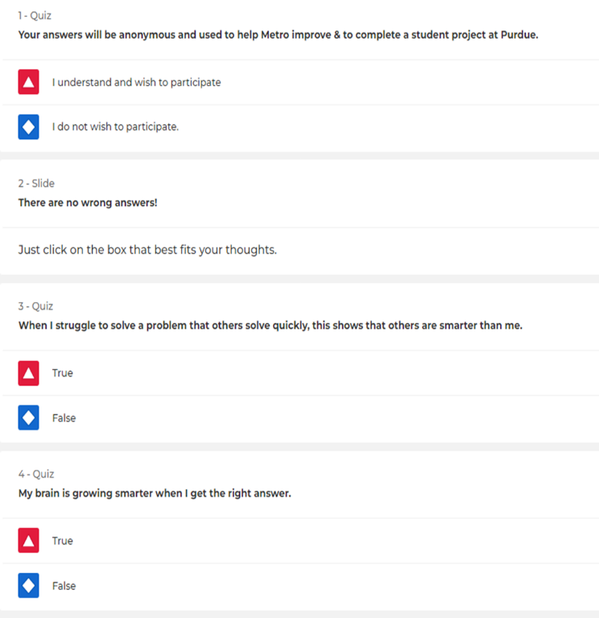

**Additional Conversation Highlights**

* The desire for a broader range of tutoring options
* Change in the interpretation of uncomfortable feelings when challenged by new math concepts
* Reasons why people might take a GED break: Health, lack of support, family situations, lack of dedication

[Click Here to see the complete set of questions](https://1drv.ms/p/s!ArL4V-vhEgNlgYw4fso1dNLQ0Dj-8w). Please note that this survey became a discussion guide because of technology challenges.

[Click Here to see Jo Boaler's (2021) intervention video](https://youtu.be/bxrPy1fjVU4).

**Appendix H**

**Job Aid for UVI, Gradual Release, and Exit Ticket Form**

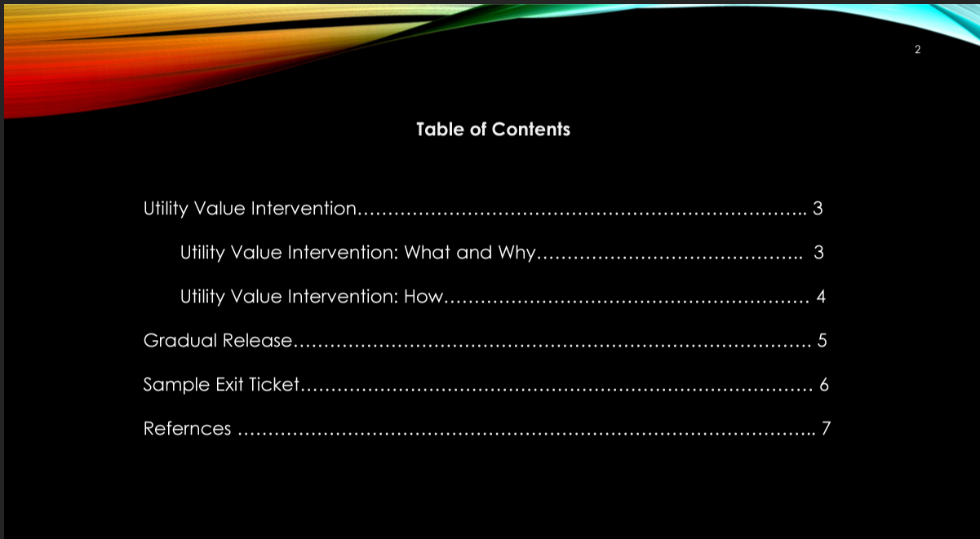

[Click here to see the full learning product](https://1drv.ms/p/s!ArL4V-vhEgNlgYwvnlpDFq0IYCzwiA).

**Appendix I**

**Padlet Discussion Board Screenshot**



[Click here to enter the discussion board](https://padlet.com/mrsmichelemichaelis1/mcc-ged-instructor-discussion-board-o4n42y8ka1x04rli).

## **Practicum Reflection - Narrative**

**What was learned from completing the project?**

I still absorb the experience, so this answer will likely be incomplete. This project was not an "order" I tried to fulfill with a learning product. I was tasked to find out why some students were leaving the GED program with only one test left to take. So, I had to start from ground zero. I found out it is a lot of work. One experience worth sharing is that I initially assumed that most of the unfinished tests would be social studies or science. I assumed this because of GED students at Metropolitan Community College (MCC). However, taking the time to analyze appropriately showed that this assumption was wrong. It showed me the value of getting all the facts before guessing the problems.

**What were the key challenges and benefits of working on this project?**

***Challenges:*** Obtaining enough volunteers to get useable results was a challenge. Although I did have some strangers participate, most who were excited to help had personal connections to me. I also had an unusual technology issue with Kahoot, which has always been reliable. So, I had to adjust and use the intervention survey as a discussion guide with my focus group.

***Benefits:*** I just got an email from my project supervisor, who has seen a rough draft of my paper. She wants me to share the results with the executive staff. It sounds like there may be a possibility that this plan could be implemented in the future. This opportunity would be great because a full-scale implementation and evaluation would allow for the completion of this project. I would love to see this project from end to end.

**Now, with hindsight, what could have been changed to improve the project in a significant manner?**

In hindsight, I would have rearranged some of my tasks when survey results were slow. I could have been working on removing identifying features on data reports as they came in and creating pie charts and bar charts immediately. Although I did not know some of this, I should have been more proactive.

I might also try to have a pizza party focus group if I am trying to get information from former students who may have little interest in helping the organization.

**Which of your ID skills do you feel were improved because of the project, and which skills still need more work?**

The in-depth focus on systemic analysis for a real-life organization was a great first-time experience. I have had a lot of experience designing learning projects through teaching, and although I did design and evaluate my curriculum based on a bit of analysis, those projects never encompassed a detailed report like this. I have a much better idea of what it means to manage a project end to end. And I have a much deeper understanding of an end-to-end learning design project's intensity.

The next thing on my list is improving my evaluation skills, mainly calculating an ROI. I was hoping for more financial information during this project to calculate the cost of a student leaving after passing three out of the four tests. But this information seemed challenging to find. If my project grows into something implemented, I hope to access some of that information and strengthen the evaluation skills I might need to prove to a business that the learning plan was adequate.